Crawl Identification- Student Sheet
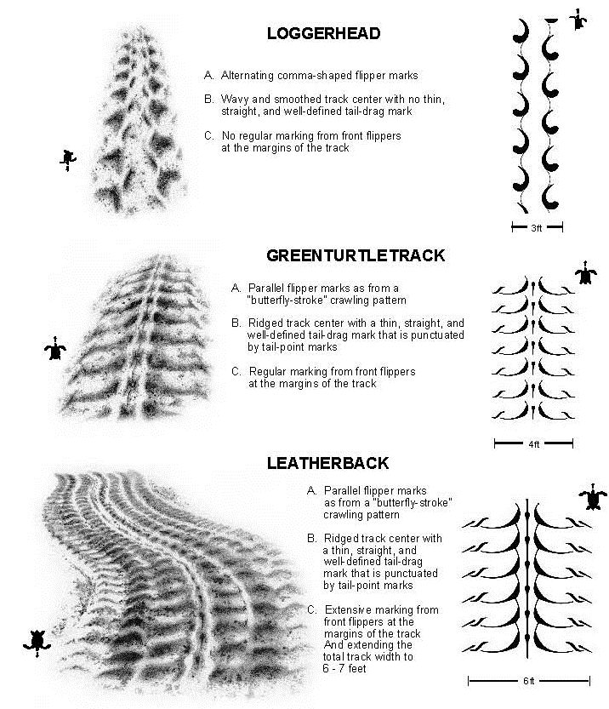

Reprinted with permission from the Florida Department of Environmental Protection
For the complete guide visit: http://myfwc.com/media/201274/CRAWL_Identification_Guidelines.pdf

Nesting Data Sheet
 | Species | Identifying Characteristics
Our Nest
Group 1
Group 2
Group 3
Group 4
Group 5

Nesting Data Sheet
 | Species | Identifying Characteristics
Our Nest
Group 1
Group 2
Group 3
Group 4
Group 5

