Welcome to North Carolina
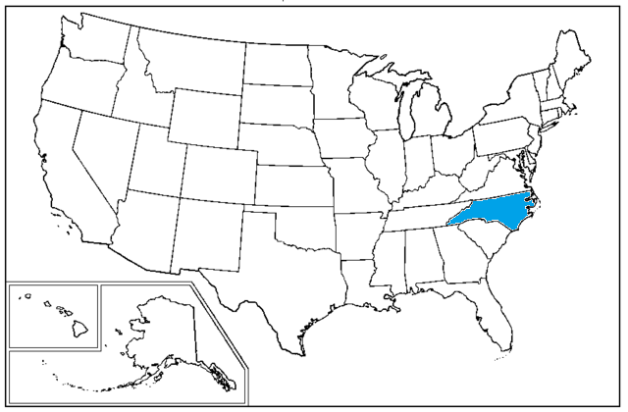
North Carolina is located in the southeastern United States. It is the 28th largest state with 53,819 square miles of land. It is bordered to the east by the Atlantic Ocean, to the north by Virginia, to the west by Tennessee, and to the south by South Carolina. Today North Carolina is home to over 9,752,000 people. The capital, Raleigh, and Charlotte are two of the country’s ten fastest growing cities. The state has become a popular tourist destination with 34 state parks, and 14 national parks.

North Carolina has three distinct geographic areas. The Smoky Mountains make up 20% of the state. The piedmont, or plateau sloping from the mountains to the ocean, makes up 35% of the state. The coastal plain makes up almost half of the state at 45%. North Carolina has 301 miles of coastline and includes many barrier islands. Being on the coast, North Carolina is the second most likely state to be hit by a hurricane.

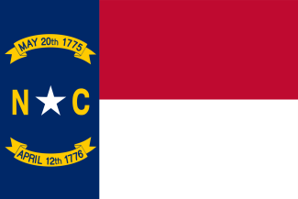
Prior to European settlement, North Carolina was home to approximately 30 Native American tribes including the Cherokee, the Catawba, the Tuscarora, and the Croatans. North Carolina was one of the original colonies when the United States declared independence in 1776. After the American Revolution, it became the 12th state in the Union.

For many years, inhabitants of North Carolina used sea turtles as a source of food and income. Catching sea turtles was one of the first commercial fisheries in southeastern United States. Sea turtles were abundant and easy to catch when they came ashore to nest. Green sea turtles got their name because hunters noticed their meat was greenish in color. Not only were turtle meat and eggs a staple in many diets but the shells were often used for jewelry and other trinkets. This continued until the 1970s when sea turtles were protected. Hawksbill, Kemp’s Ridley and Leatherback turtles were protected in 1970 where as green, loggerhead, Olive Ridley turtles were covered by the Endangered Species Act in 1978.

Welcome to Belize
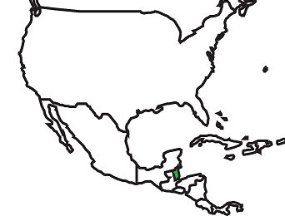
Belize is located in Central America. It is bordered on the east by the Caribbean Sea, to the north by Mexico, and to the west and south by Guatemala. Until 1981 Belize was a British Colony called British Honduras and Queen Elizabeth II is still the head of state. She is supported by a Governor and a Prime Minister. Belize is home to over 340,844 people. While English is the official language, some people also speak Belize Creole (Kriol) or Spanish.

Belize is a rather small country with only 8,867 square miles of land. It has two major geographic regions: the Maya Mountains, which includes the surrounding basins and plateaus, and the coastal plain, which includes many islands, called cayes (pronounced keys), and the second largest barrier reef system in the world. As a coastal country, Belize is threatened by hurricanes.

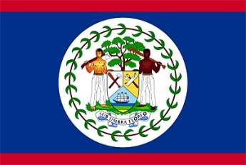
Prior to Spanish exploration, Belize was home to several Mayan communities. The Spanish came to find gold but moved on when there was none to be found. Later the area was settled by Englishmen who began logging for mahogany. They brought in slaves from West Africa to help with the logging. These cultures are still found in Belize today. There are still Mayan communities and there is a thriving Creole culture founded by the early slaves. Much of the population is considered Mestizo, as a mix of Mayan and Spanish ancestry.

For many years, when logging and piracy was still common, sea turtles were an important export for Belize. Sea turtle meat was often smoked and sold to passing ships. It was also exported to England when it became a delicacy overseas. Hawksbill turtles were overfished for their decorative shells. Belize did not have any regulations on sea turtles until 2002. It is now illegal to harvest sea turtles in Belize.

Gullah, Geechee, and Creole
North Carolina was home to many enslaved communities. From these communities came rich and diverse cultures including the Gullah communities. The Gullah/Geechee Cultural Heritage Corridor extends from Wilmington, North Carolina in the north to Jacksonville, Florida, in the south. The culture has been linked to specific West African ethnic groups who were enslaved on island plantations to grow rice, indigo, and cotton. Gullah is typically used for the communities in the Carolinas whereas Geechee refers to groups in Georgia and Florida. The Gullah/Geechee speak the only African American Creole language developed in the United States. It combines elements of English with over 30 African dialects.

Much of the Gullah/Geechee culture survived after the Civil War. Since many of these communities were on islands, they were isolated from outside influences. This changed in the 1950s when the islands became desirable for resorts. There is a movement to strengthen the Gullah/Geechee culture and spread awareness of these communities.

Belize has a similar culture called Creole (which is often spelled Kriol). Creole people are descendents of slaves brought from West Africa to Belize for the logging industry. Because the slaves worked so closely with the loggers, they combined elements of both languages. Their children and grandchildren passed on the culture and language of Creole. Although English is the official language of Belize, many people speak Kriol in informal settings. In the 1990s there was a big movement to strengthen the Kriol language. A Kriol – Inglish Dikshineri was created to help more people learn the language.

Creole languages were created by the interactions between masters and slaves in the holding cells of Sierra Leone in West Africa all the way to the coasts of Georgia and the Carolinas. Bringing slaves from western Africa across the Atlantic to the Central American Caribbean coastal areas of Belize, Nicaragua, Panama, Costa Rica further contributed to the development of the language. A Creole language can be thought of as the result of the combination of a colonizer's language with the grammar of one or more African languages. The Caribbean and Atlantic Coast regions have Creole languages that are either based in English, French, Dutch or Spanish; it depends on which country colonized the area.

Resources:
National Park Services. Gullah/Geechee Cultural Heritage Corridor North Carolina, South
Carolina, Georgia, Florida. n.d. 3 September 2014. <http://www.nps.gov/nr/travel/
cultural_diversity/Gullah_Geechee_Cultural_Heritage_Corridor.html>.
Sumpter, Althea. Geechee and Gullah Culture. 31 March 2006. 3 September 2014.
<http://www.georgiaencyclopedia.org/articles/arts-culture/geechee-and-gullah-culture>.
Woods, Silvana. Say it like d' Belizean. Ed. Naturalight Productions. n.d. 3 September
2014. <www.belizeanjourneys.com/features/kriol/newsletter.html>.

Sea Turtle Range Maps
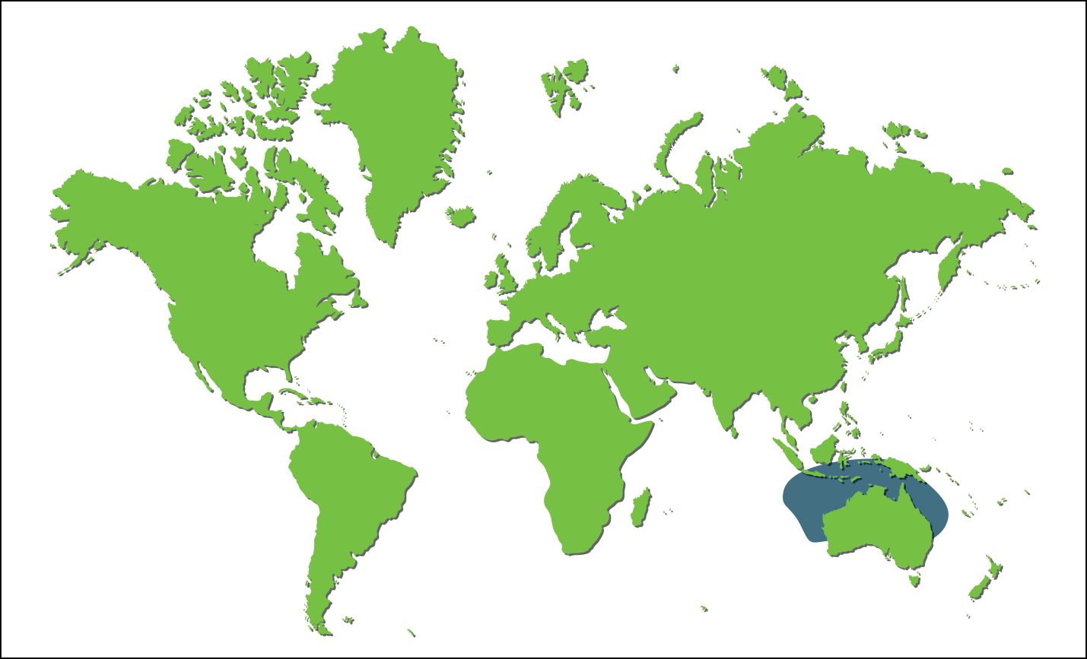
Flatback Range Map
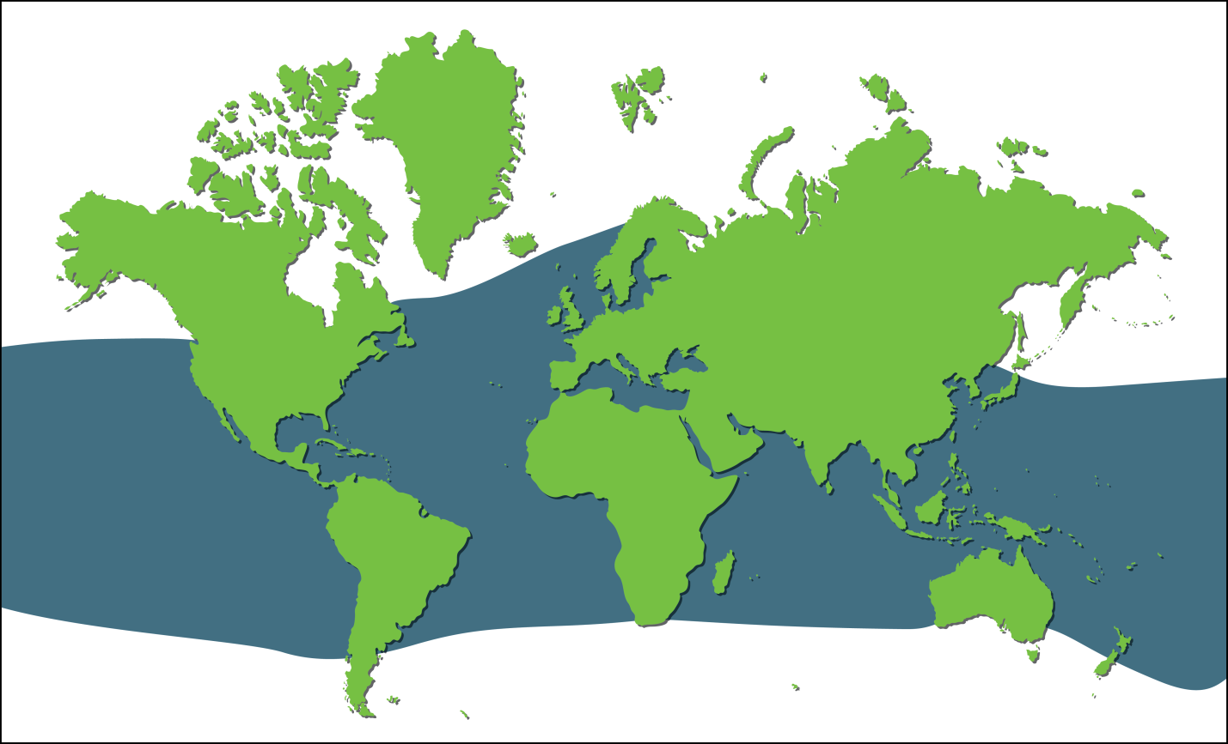
Green Range Map
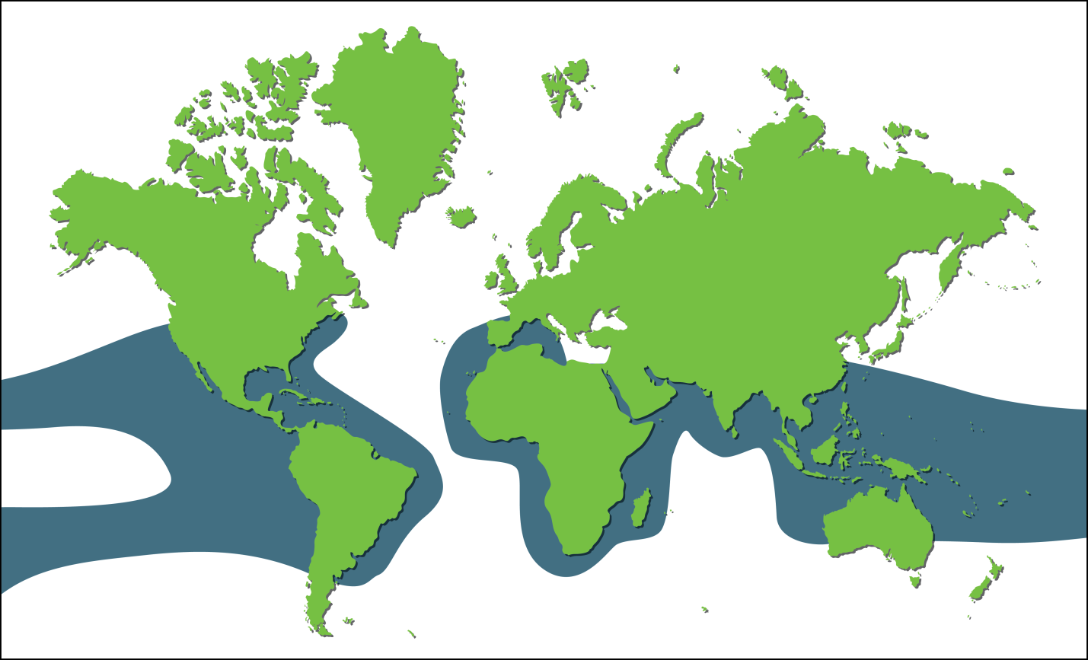
Hawksbill Range Map
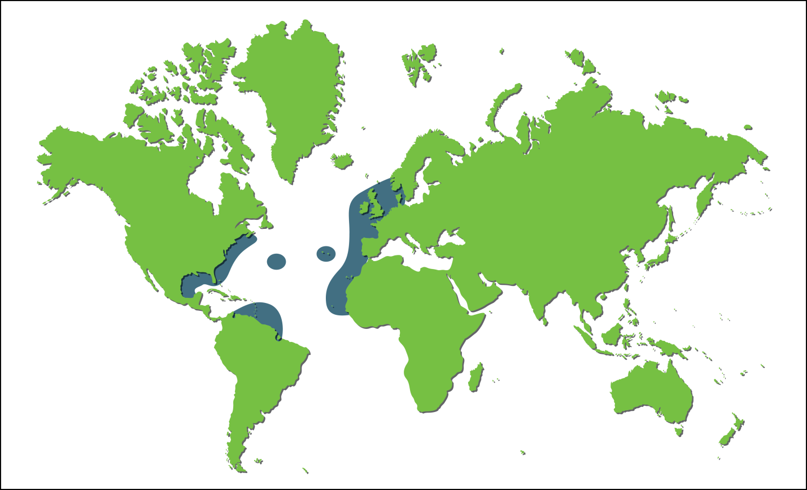
Kemps Ridley Range Map

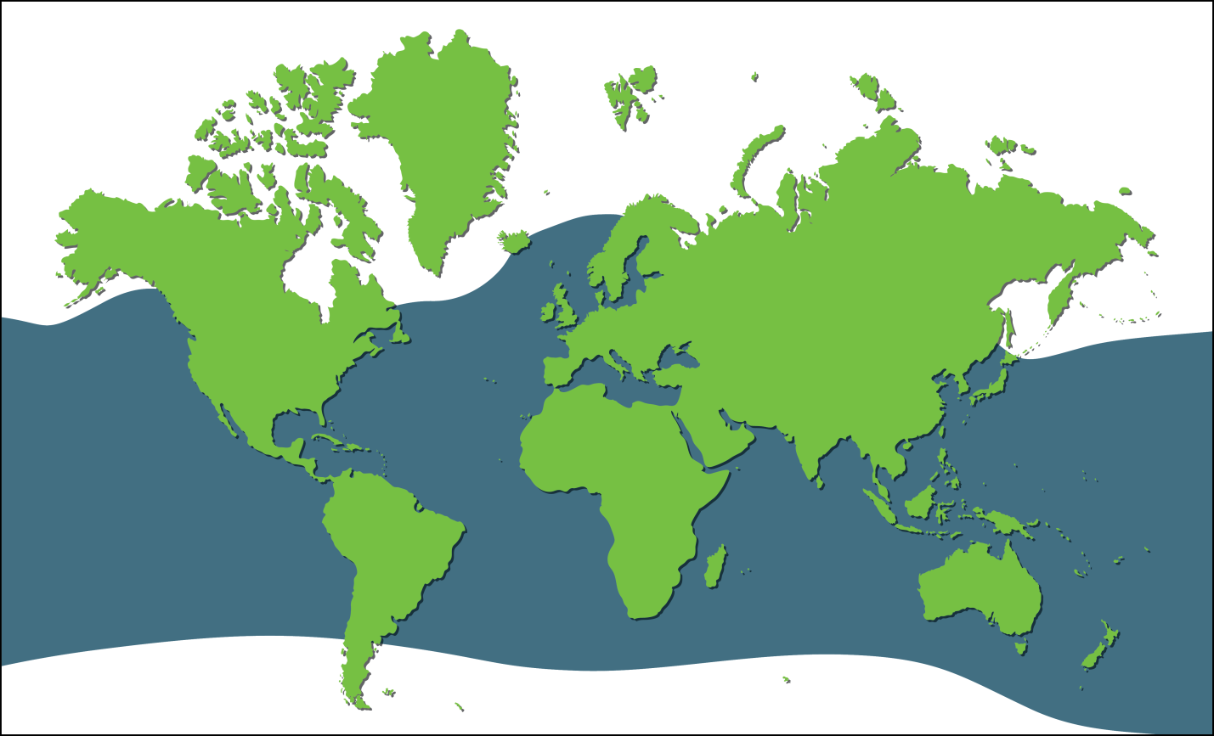
Leatherback Range Map
Loggerhead Range Map

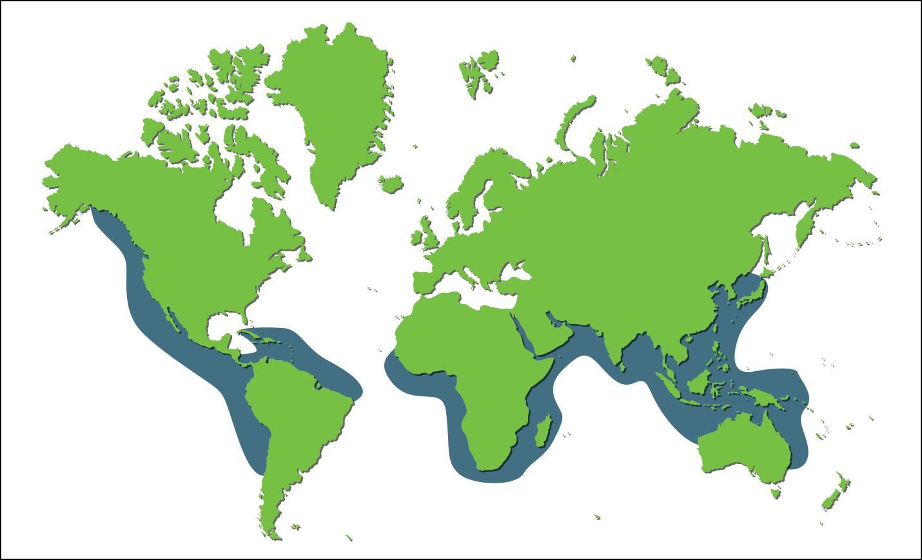
Olive Ridley Range Map

Comparing North Carolina and Belize
 | North Carolina | Belize
What is the title of the Leader?
What year did the country gain its independence?
What is the population size?
What is their capital?
What are the colors of the flag?
What type of money is used?
What is/are the major language(s)?
How much land area do they have?
What are three geographic features?
What is the coastline length?
What types of sea turtles are found there?
What year were sea turtles protected?
Are hurricanes a threat?
Color North Carolina Blue and Belize Green
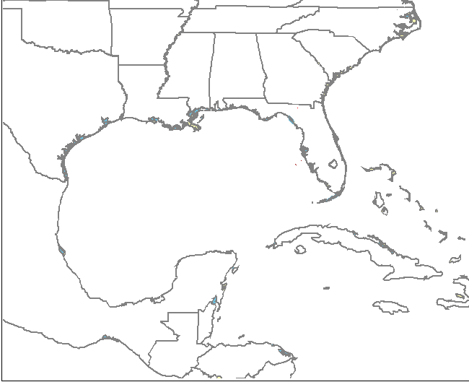
Answers
 | North Carolina | Belize
What is the title of the Leader? | Governor (or President of USA) | Queen of England is represented by a governor and a prime minister
What year did the country gain its independence? | 1776 | 1981
What is the population size? | 9,752,000 (2012) | 324,060 (2012)
What is their capital? | Raleigh | Belmopan
What are the colors of the flag? | Red, white, blue, gold | Red, white, blue and seal. It is the only flag in the world with people on it. 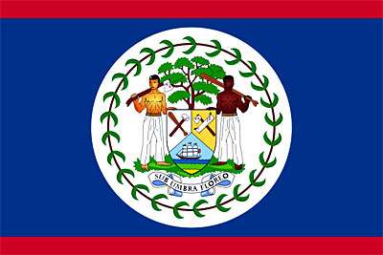
What type of money is used? | US Dollar | Belizean Dollar
What is/are the major language(s)? | English | English (National Language), Creole, Spanish
How much land area do they have? | 53,819 sq miles | 8,867 sq miles
What are three geographic features? | Mountains, piedmont, Coastal plain, barrier islands | Mountains, coastal plain, barrier reefs
What is the coastline length? | 301 miles (all shorelines 3,375 miles) | 240 miles
What types of sea turtles are found there? | 3 most common: loggerhead, green, leatherback | 3 most common: loggerhead, green, Kemp’s Ridley
What year were sea turtles protected? | 1970s (Hawksbill, Kemp’s Ridley and Leatherback in 1970, Green, Loggerhead, Olive Ridley in 1978 with Endangered Species Act) | 2002
Are hurricanes a threat? | Yes | Yes

Weh Wi Ga Fi Seh" Weekly Kriol Article:

Di Kriol Langwij
bai Priscilla Brown-Lopez

Sohn pipl seh,
“Noh taak braad Kriol”
Noh tel mi: Ah noh waahn noa how
Ai noh di taak like dat!”

Yu meen fi seh, yu noh si weh Ah gat?
Yu noh mee ejukaytid?
Ai gat mi digree ahn mee “elevated.”
Mi hed maita tof, bot now Ah noa nof.
Ah shaap-op wid mi hai heel,
Ah kyaahn eebn tel yu how Ah feel!

Yu eva yehr wahn Spanish man
Frayd fi taak ih langwij?
Er wahn Inglish man
Di chrai fi haid ih heritij?
Soh luk ya man,
Pleez chrai fi andastan!
Yoo ahn mee da Kriol man ahn uman.
Andastan wi kandishan.
Noh geh rifain
Ahn figet yu kain.
Tek wahn stan.
Memba aal a wi da wan.

Wi ga wi tingz fi feel prowd fa.
An wi hafu stan shoalda tu shoalda.
Memba wi ansestaz
Ahn aal weh dehn mi stan fa.
Now wi ga wi Kriol dikshineri,
Soh yu noh hafu wori.
Ah noa yu ku manij
Fi taak ahn reed ahn rait di Kriol langwij.

(Wi tank Priscilla-Brown Lopez fu dis Kriol poayem! Yu ga sohnting yu waahn shyaa wid wi? Jos rait tu wi da Reporter er tu Di Bileez Kriol Projek, P.O. Box 1964, Belize City, Belize.)

Article Entered on 22/08/2014
http://www.belmopancityonline.com/kriol-language.aspx

